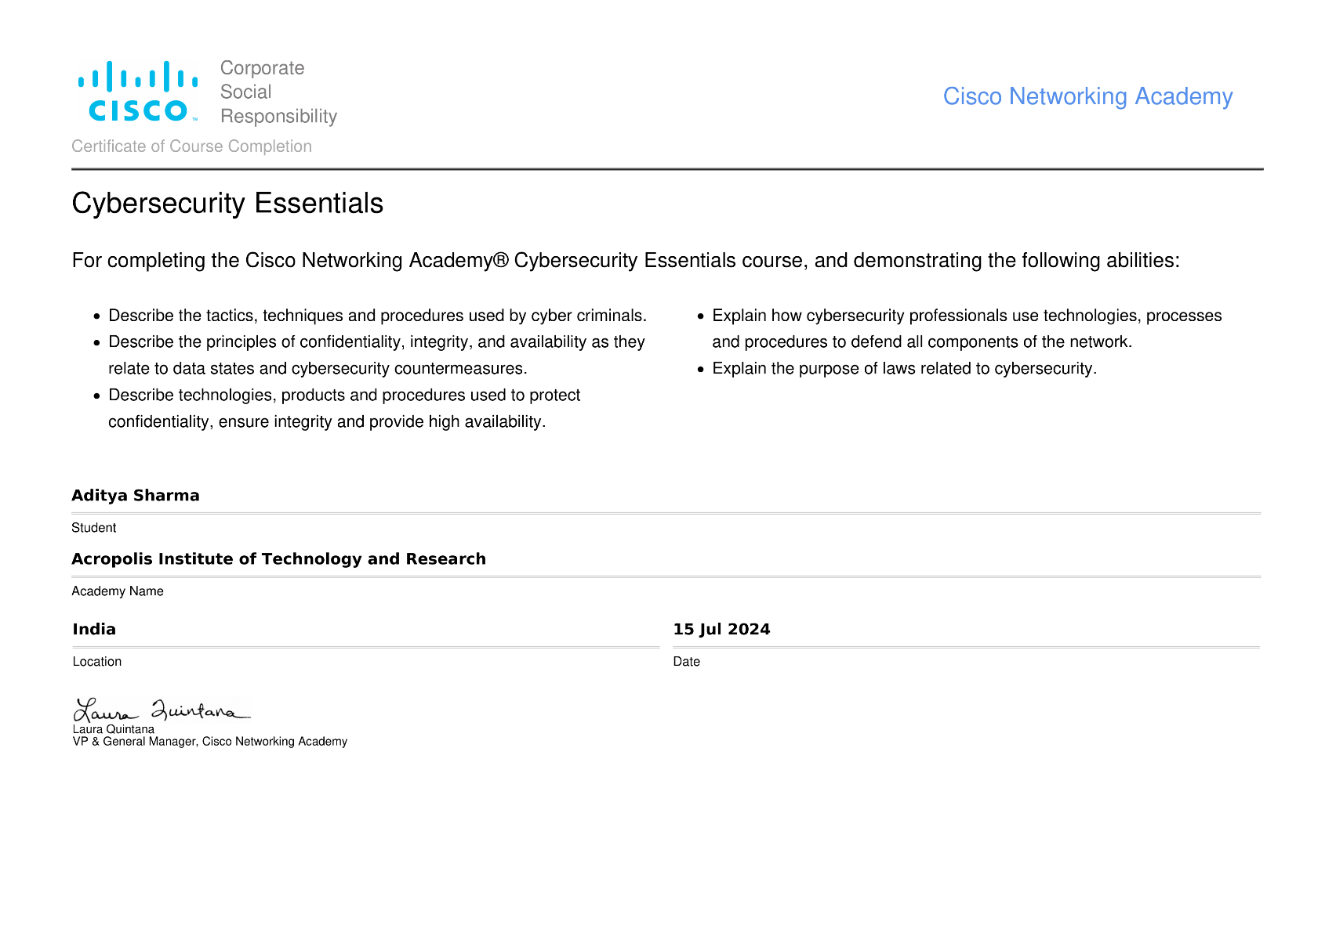 

**ACROPOLIS INSTITUTE OF TECHNOLOGY & RESEARCH, INDORE**

**Department of**

**Computer Science & Information Technology**

III Year, Vth Semester (July-Dec,2024) (Batch 2022-2026)

**Submission of**

**EVALUATION OF INTERNSHIP REPORT BT 407**

Submitted to: Submitted by:

**Prof. Shruti Lashkari Aditya Sharma**

**ACROPOLIS INSTITUTE OF TECHNOLOGY & RESEARCH, INDORE**

**Department of Computer Science & Information Technology**

# Training Certificate

Certified that training work entitled “*Linux Operating System and MATLAB*” is a Bonafide work carried out after Vth semester by “*Aditya Sharma 0827CI221012*” in partial fulfilment for the award of the degree of Bachelor of Technology in Computer Science and Information Technology from “*Dr. Nidhi Nigam, Prof. Chanchal Bansal*” Acropolis Institute of Technology and Research during the academic year 2024-25.

Name and Sign of Coordinator

**ACROPOLIS INSTITUTE OF TECHNOLOGY & RESEARCH, INDORE**

**Department of Computer Science & Information Technology**

# ACKNOWLEDGEMENT

I would like to acknowledge the contributions of the following people without whose help and guidance this report would not have been completed. I acknowledge the counsel and support of our training coordinator and EOI coordinator, *Prof. Shruti Lashkari*, CSIT Department, with respect and gratitude, whose expertise, guidance, support, encouragement, and enthusiasm has made this report possible. Their feedback vastly improved the quality of this report and provided an enthralling experience. I am indeed proud and fortunate to be supported by him/her. I am also thankful to Dr. Shilpa Bhalerao, HOD of Computer Science Information Technology Department, for her constant encouragement, valuable suggestions and moral support and blessings. Although it is not possible to name individually, I shall ever remain indebted to the faculty members of CSIT Department, for their persistent support and cooperation extended during this work.

Student Name: Aditya Sharma

Student Enrollment No.: 0827CI221012

**ACROPOLIS INSTITUTE OF TECHNOLOGY & RESEARCH,**

**INDORE INDEX**

|  |  |  |
| --- | --- | --- |
| **S.No** | **CONTENTS** | **Page no** |
| 1 | Introduction of technology undertaken during training (if any) Details of Training  Details of Technology undertaken  Outcome/Certification/Project if done during training | 1 |
| 2 | Project undertaken in OSSL | 3 |
| 3 | Report of LeetCode/CodeChef | 5 |
| 4 | Global Certificate Achieved if any | 7 |
| 5 | Any other certifications achieved/ Participation in Hackathons/Internship with  takeaways etc. | 10 |
| 6 | NPTEL Certificate details and mentor details( If not cleared ,Proof to be attached  for Registration, Admit Card, Fees receipt,) | 14 |
| 7 | References/ Bibliography | 16 |

**Introduction of technology undertaken during training**

## Linux Basics

* + Linux is a widely used open-source operating system, especially in software development, server management, and cybersecurity.
  + The training introduced foundational concepts of Linux and its significance in personal and professional environments.
  + Learned to navigate the Linux environment using the command-line interface (CLI) for efficient system interaction.
  + Gained understanding of the Linux file system, including file and directory management.
  + Acquired skills in configuring user and group permissions for secure system operations.
  + Learned basic shell scripting, enabling automation of repetitive and complex tasks.
  + Developed a comprehensive understanding of Linux basics and its relevance in modern IT practices.

## MATLAB (Matrix Laboratory)

* + MATLAB is a high-performance programming environment used for numerical computation, data analysis, and graphical representation.
  + The training provided an in-depth understanding of MATLAB’s interactive environment and core functionalities.
  + Learned matrix operations, script writing, and the creation of user-defined functions.
  + Explored MATLAB’s applications in solving mathematical problems and performing statistical analyses.
  + Gained expertise in visualizing data through comprehensive graphs and plots.
  + Learned how MATLAB is used for simulations, algorithm development, and system modeling in engineering and science.
  + Enhanced analytical and computational skills to solve complex real-world problems efficiently.

**Outcomes/Takeaways in Detail**

### Linux Basics:

* + Acquired a thorough understanding of the Linux operating system, including its architecture and key features.
  + Developed strong skills in using command-line tools for file management, process monitoring, and system configuration.
  + Gained insights into user and group permission handling, which is critical for secure system management.
  + Learned to write and execute shell scripts to automate processes, significantly improving operational efficiency.
  + Understood the significance of open-source technologies and their applications in enterprise systems, cloud computing, and embedded systems.
  + Enhanced problem-solving skills by troubleshooting real-world scenarios during practical sessions, which deepened my grasp of Linux principles.

### MATLAB:

* + Built proficiency in MATLAB programming, focusing on its versatile use in numerical computation and technical problem-solving.
  + Mastered matrix operations, which form the core of MATLAB, enabling efficient data manipulation and algorithm development.
  + Gained expertise in visualizing data through plots, graphs, and custom visual tools, which help in interpreting results and presenting findings effectively.
  + Learned to apply MATLAB to real-world problems, such as signal processing, image analysis, and predictive modeling.
  + Improved critical thinking by creating algorithms and simulations, which are crucial for engineering and scientific applications.
  + Enhanced my ability to work with large datasets and perform statistical analyses, a valuable skill in research and data science domains.
  + Developed the capability to integrate MATLAB with other tools and technologies, broadening its applicability in multidisciplinary projects.

**Project in OSSL:**

## MSRTS – Multilingual Speech Recognition & Translation System:

#### Converts raw audio of user to text, detect language & translates it into the user-demanded language

#### Project Description: This project demonstrates conversion of raw audio message of a person to text. The goal is to perform language detection and translation tasks. For conversion of speech-to-text, text analysis, language detection and translation, the in-built audio, text-analytics, navigation, signal-processing toolboxes are used. The implementation is done in MATLAB, leveraging translation capabilities using python module named translate and integrated its environment with the MATLAB app.

#### Key Features:

### **Load Audio File:**

### The audioread function loads the audio file into the workspace.

### **Input:** An audio file specified by the path.

### **Output:** y (audio data as a waveform) and fs (sampling frequency).

### **Toolbox used:** Signal-processing toolbox

### **Speech-to-text:**

### Converts audio (y) into text using MATLAB's Speech-to-Text capabilities.

### Checks if the audio is mono and extracts the first channel if needed.

### **Toolbox used:** Audio Toolbox, for speech-to-text functionality.

### **Detect Language:**

### Uses a character frequency analysis approach to detect the language of the transcribed text.

### **Translate Text:**

### Uses Python integration within MATLAB to translate the text from the detected source language to the target language.

### This involves, initializing Python integration in MATLAB (py.sys.path), uses a Python translation library (e.g., translate) to perform translation, returns the translated text.

#### Applications:

#### Real-time Translation for Communication: Facilitates seamless cross-language communication during international interactions.

#### Accessibility for the Hearing-Impaired: Generates multilingual subtitles for live events or videos.

#### Tourist Assistance: Helps travelers communicate with locals in foreign countries.

#### Subtitling and Dubbing: Automates multilingual subtitles and voiceovers for media content.

#### Immigration and Border Services: Aids officers in communicating with diverse populations.

#### How It Works:

1. **Audio Input:** The system receives audio input in a supported format, capturing the spoken language.
2. **Speech-to-text Conversion:** The audio input is converted into text using MATLAB audio toolbox.
3. **Language Detection:** The transcribed text is analyzed to identify the source language, ensuring accurate translation.
4. **Translating Text:** The identified text is translated into the target language, providing a seamless communication experience.
5. **Output:** The translated text is displayed, allowing users to understand the original message in their preferred language.

This project serves as an excellent starting point for anyone interested in computer vision, audio processing, or interactive systems development using MATLAB.

**Project undertaken with GitLink / Presentation Slides**

[**https://drive.google.com/drive/folders/1uYYtIJK8o69nmsAQufuDKqYMAslNpJ5R**](https://drive.google.com/drive/folders/1uYYtIJK8o69nmsAQufuDKqYMAslNpJ5R)

[**https://github.com/R-8-12/MSRTS-Multilingual-Speech-Recognition-and-Translation-System.git**](https://github.com/R-8-12/MSRTS-Multilingual-Speech-Recognition-and-Translation-System.git)

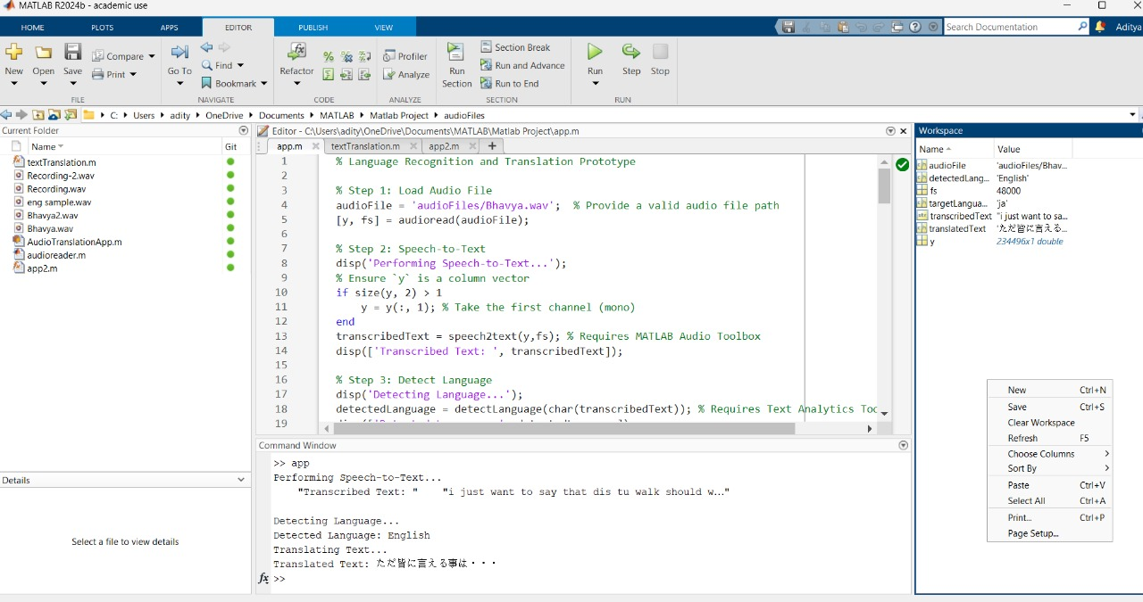

**Proof of No. of Problems solved in LeetCode**

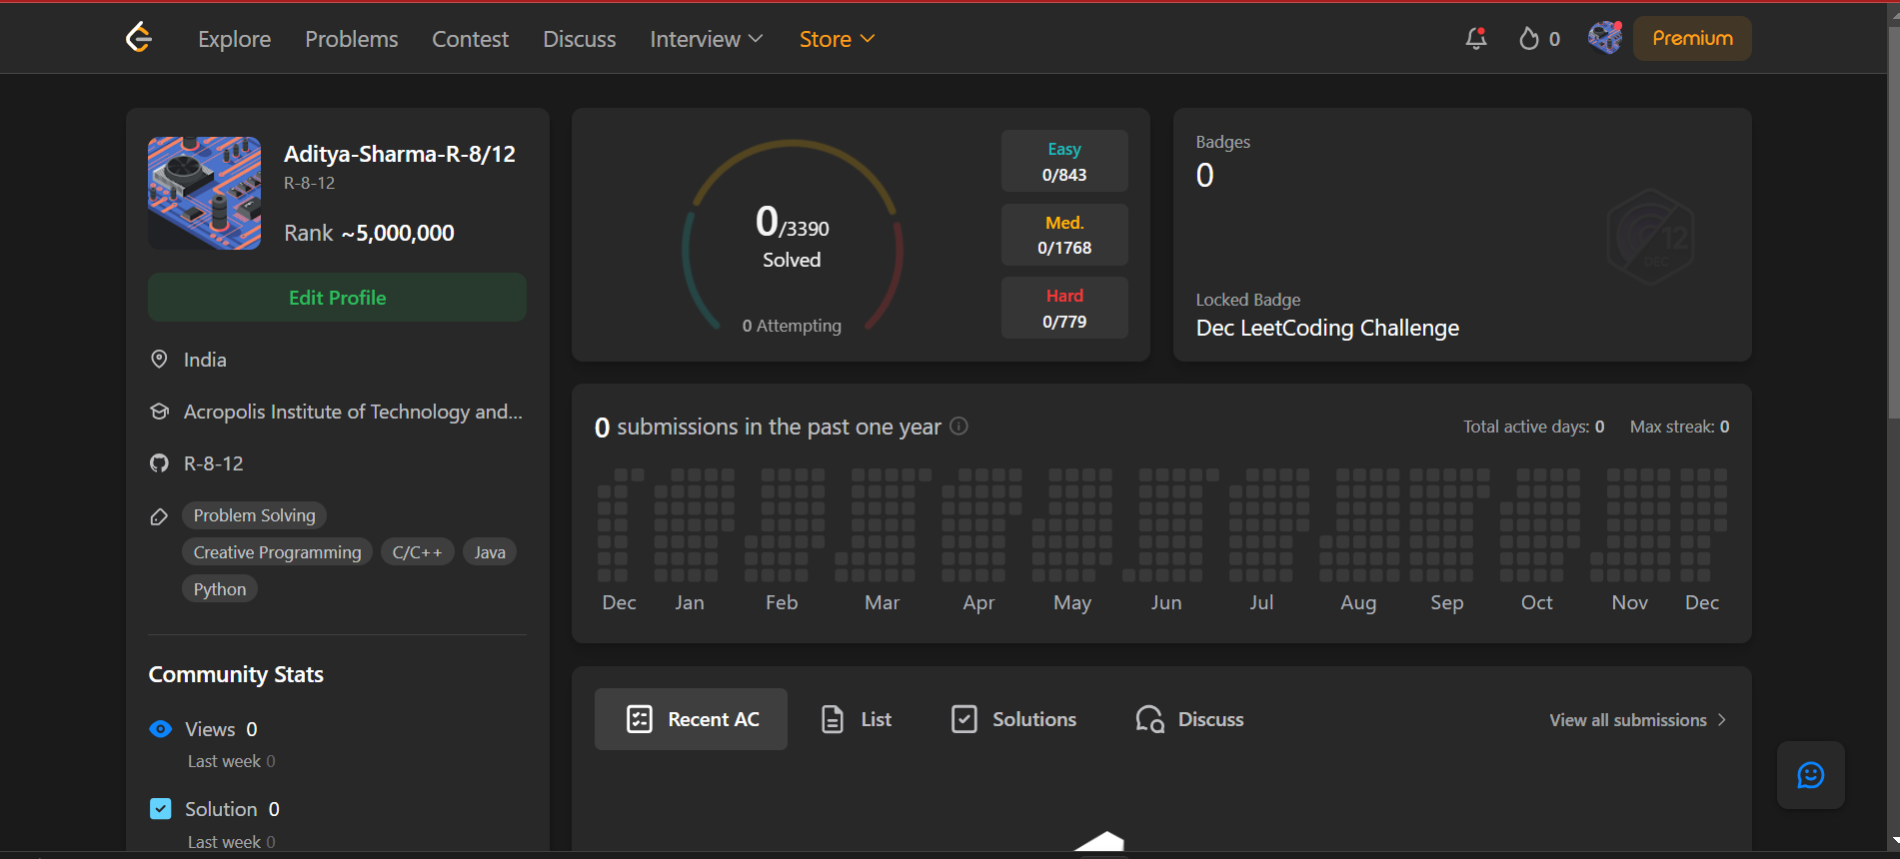

**Proof of No. of Problems solved in HackerRank**

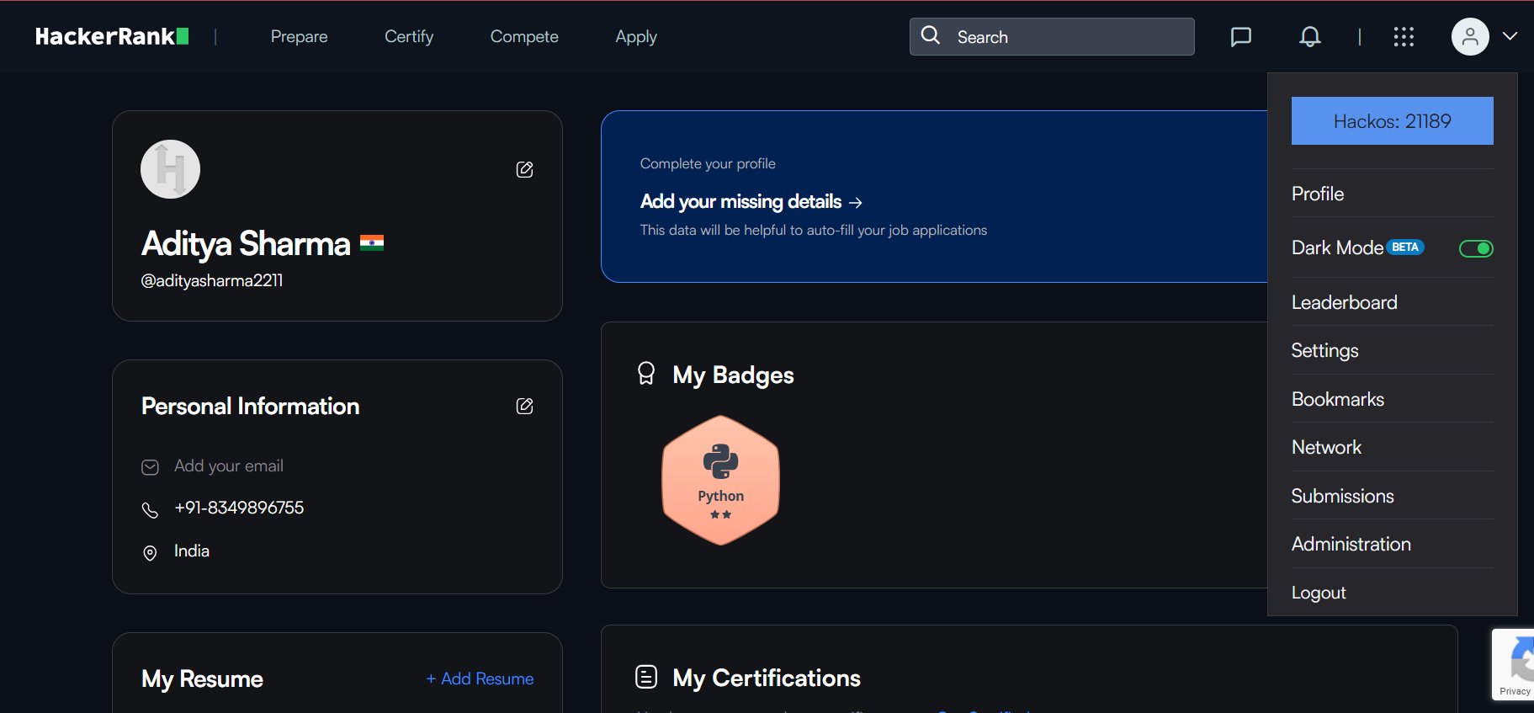

**Proof of No. of Problems solved in CodeChef**

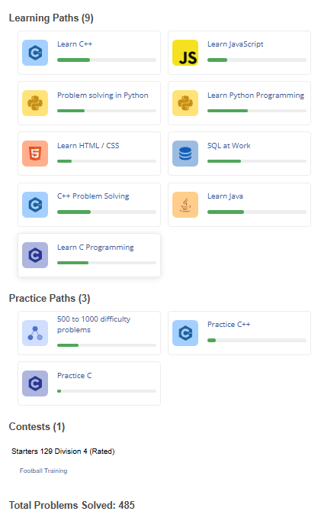

**Global Certification:**

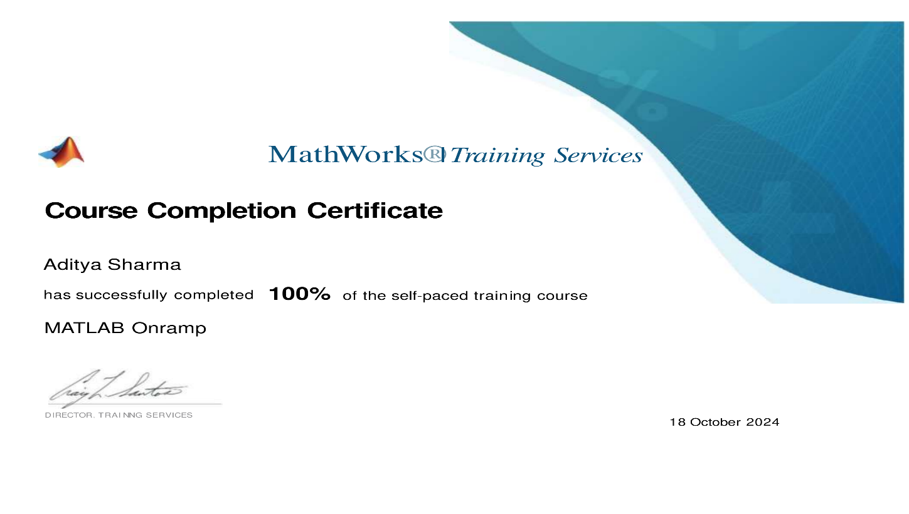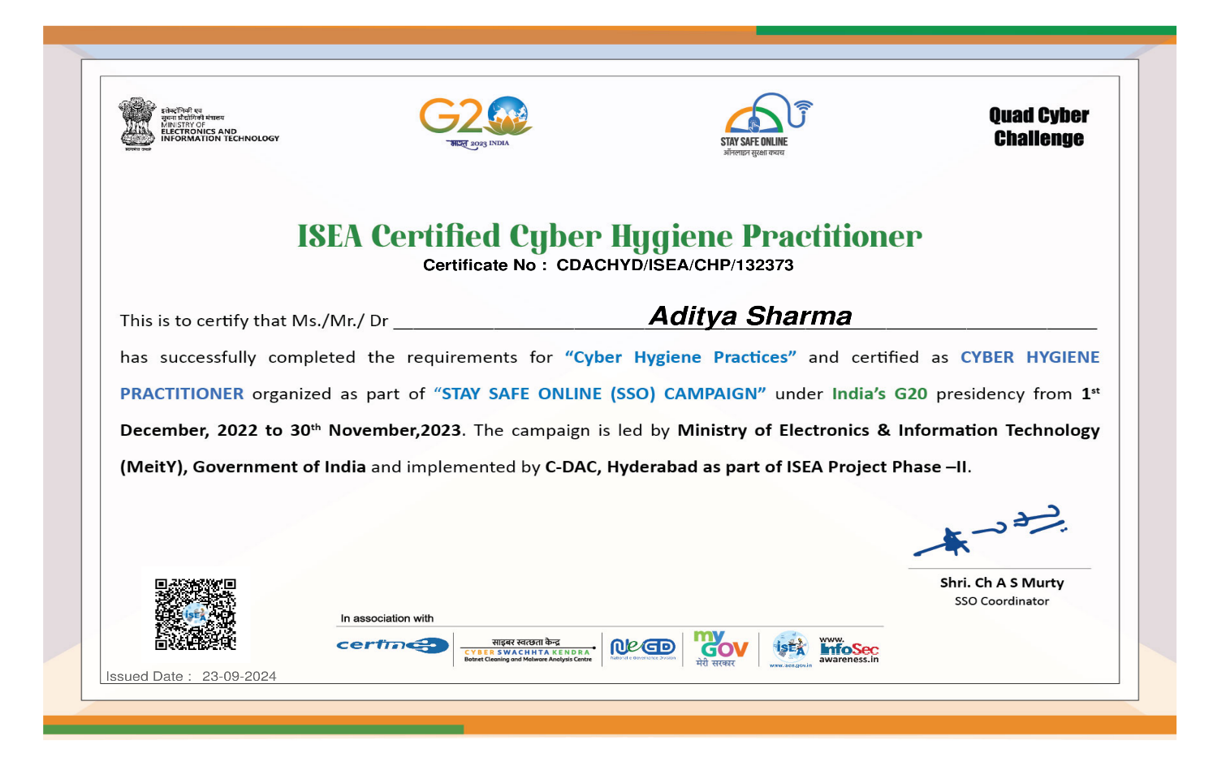

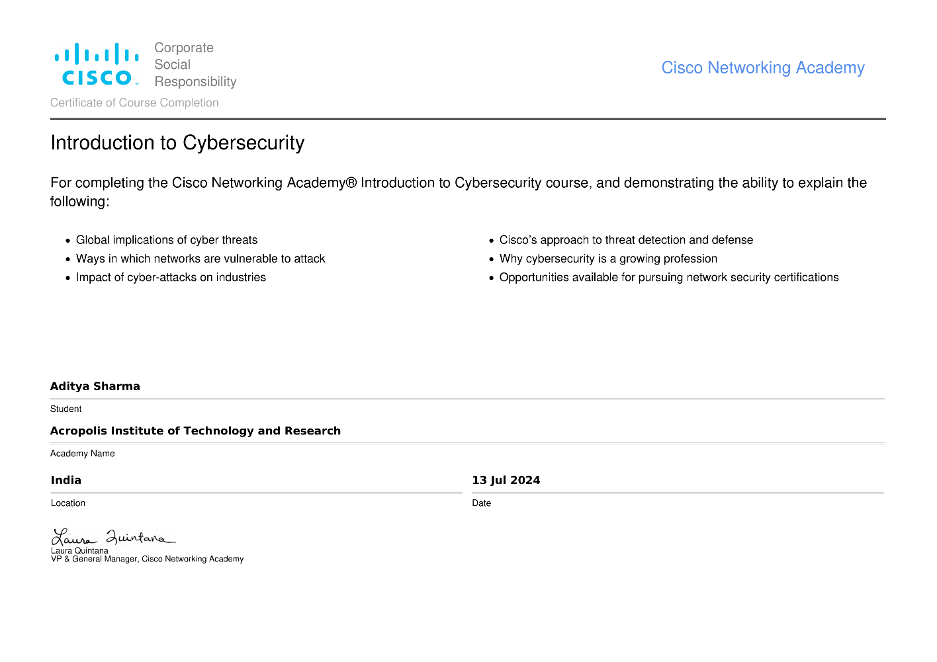

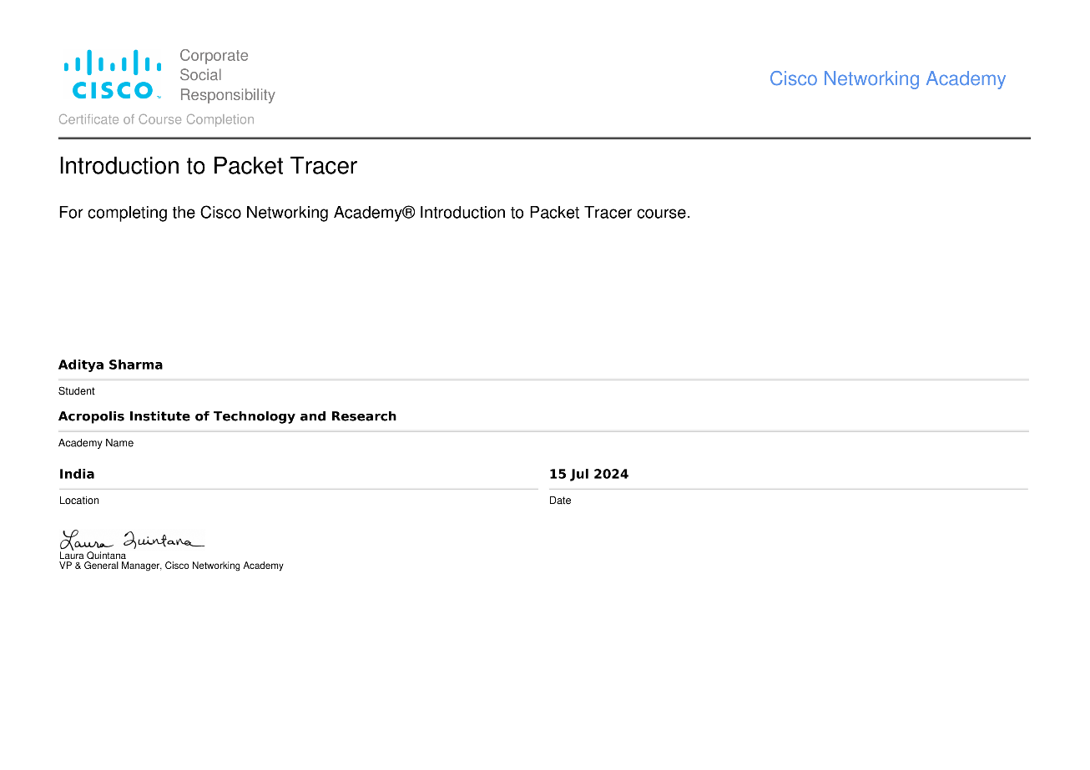

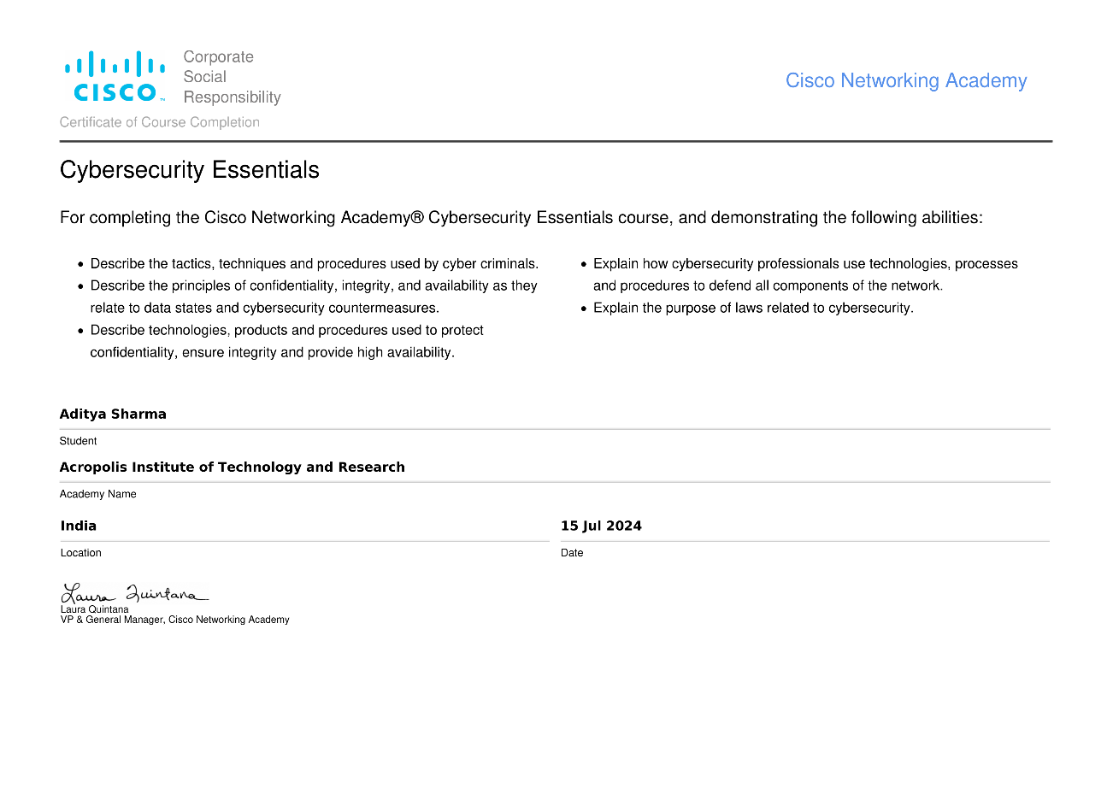

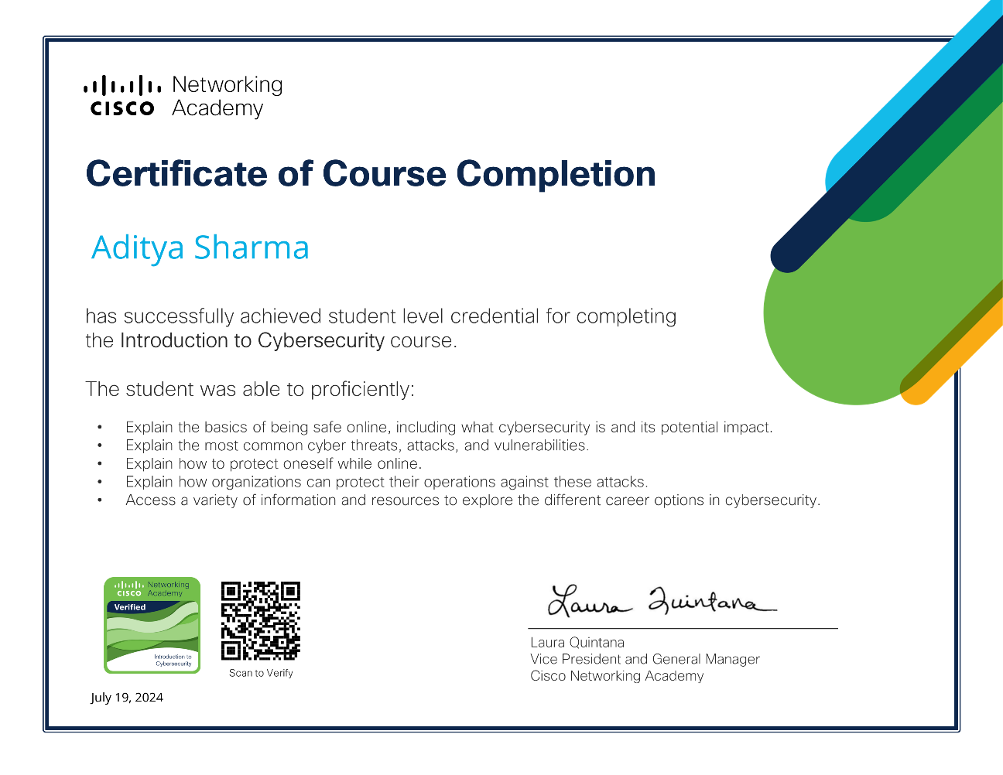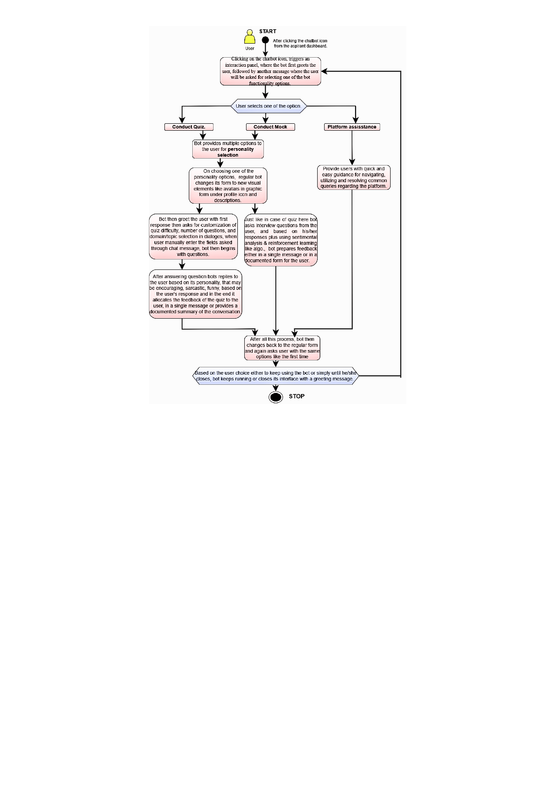

**Regional Certificate:**

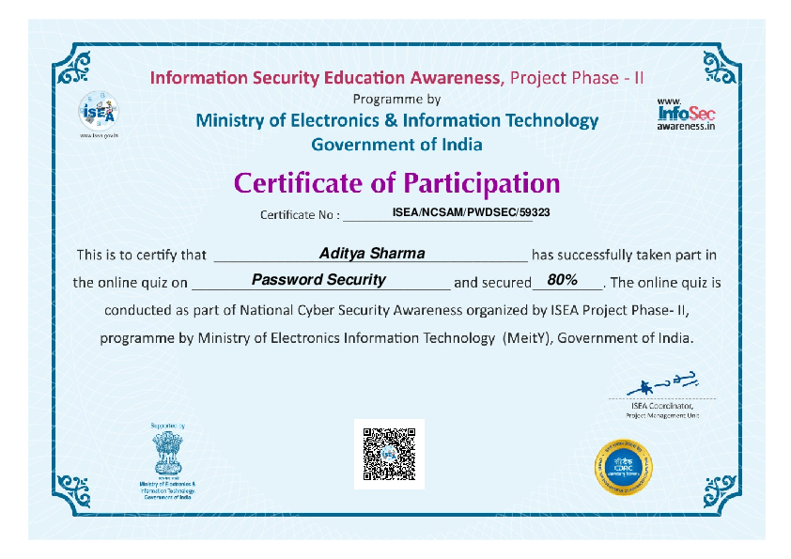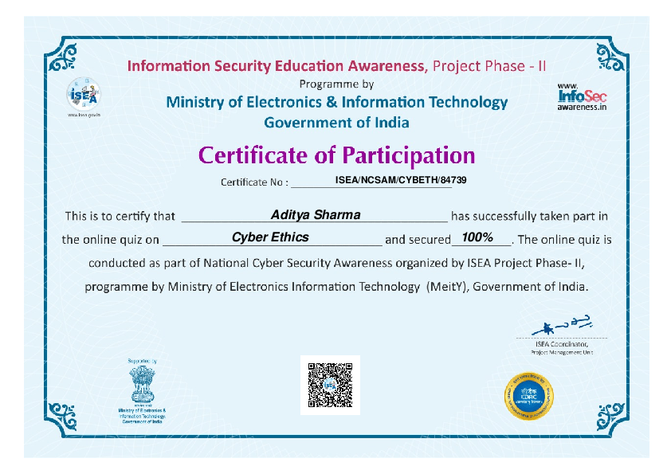

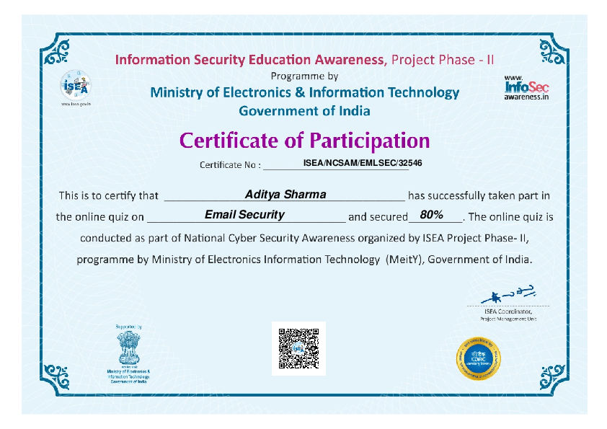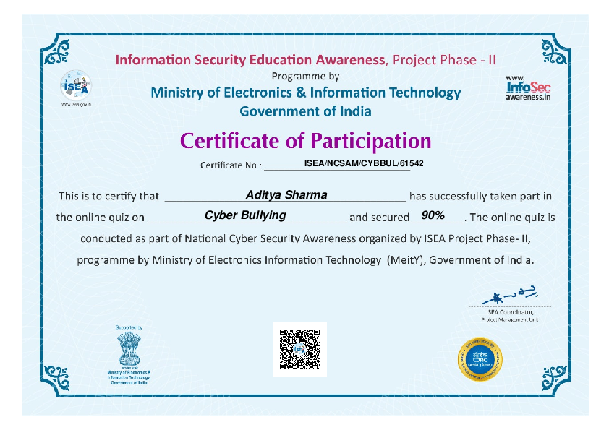

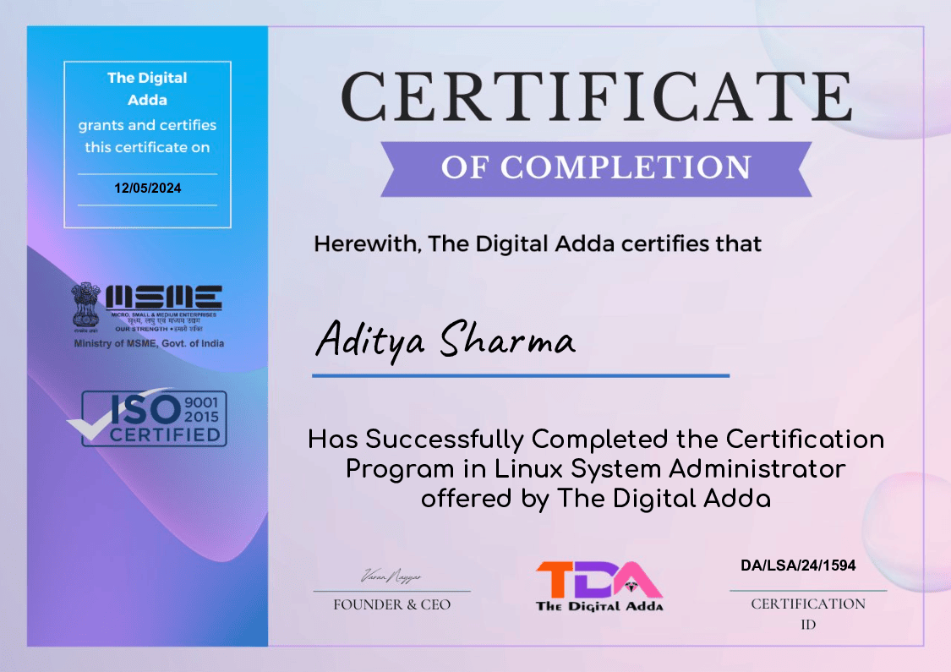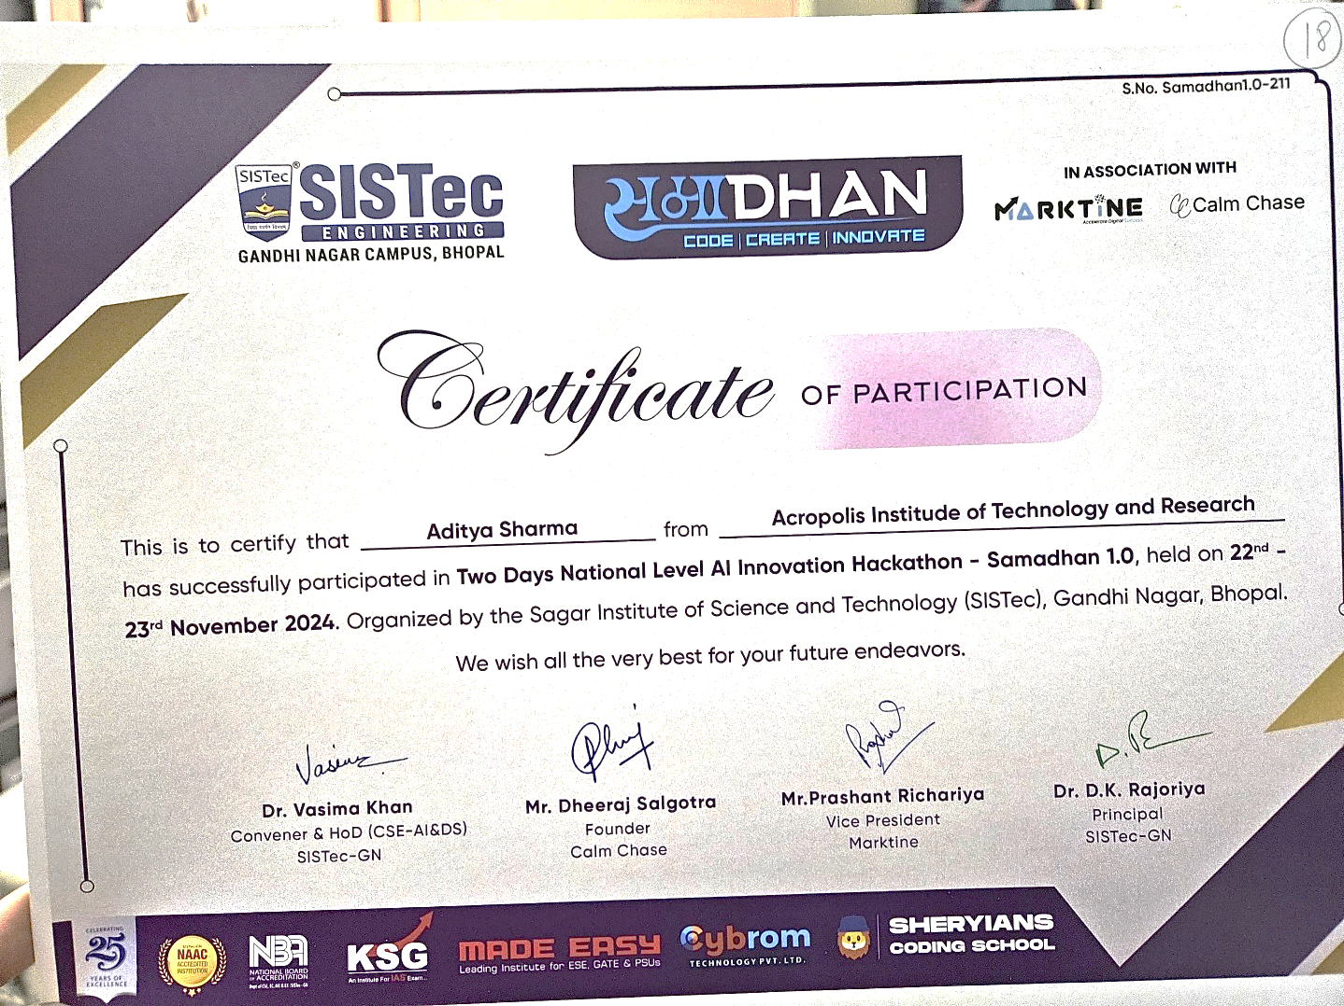

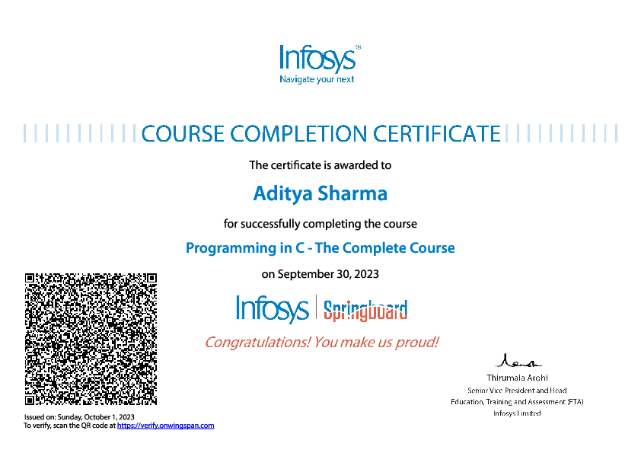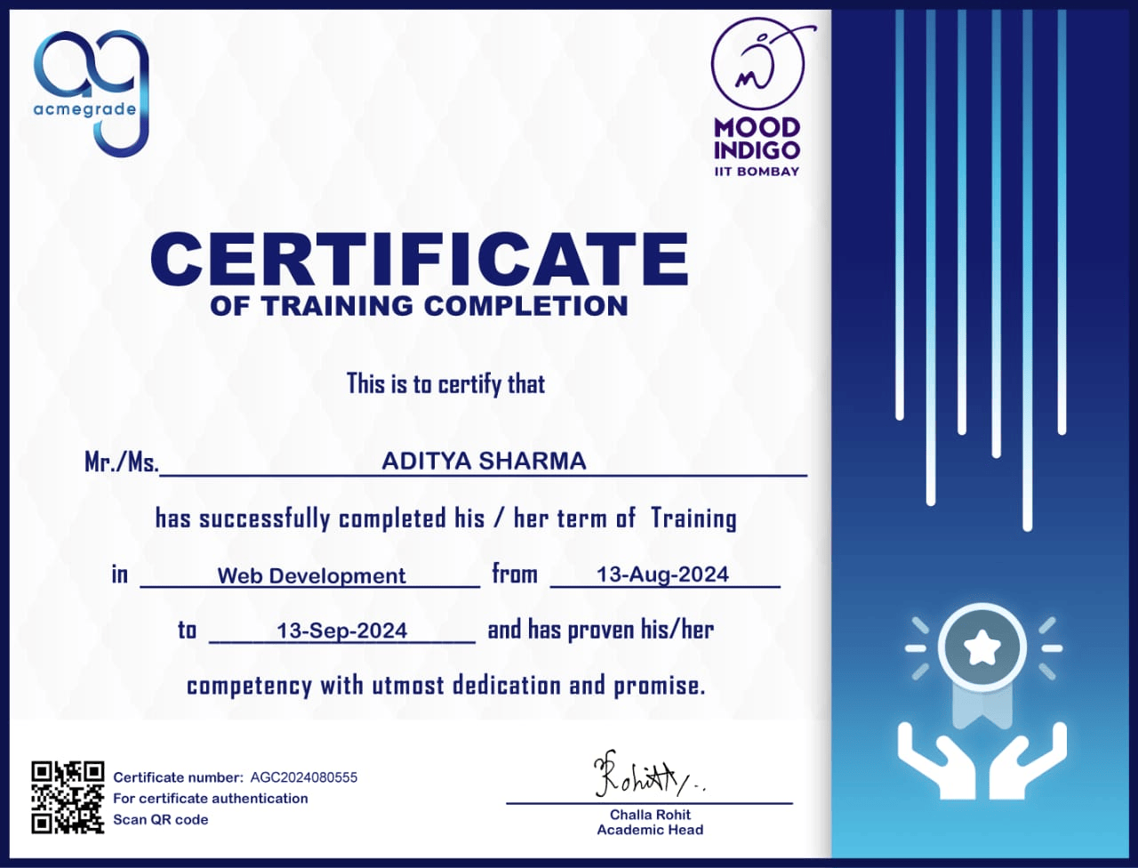

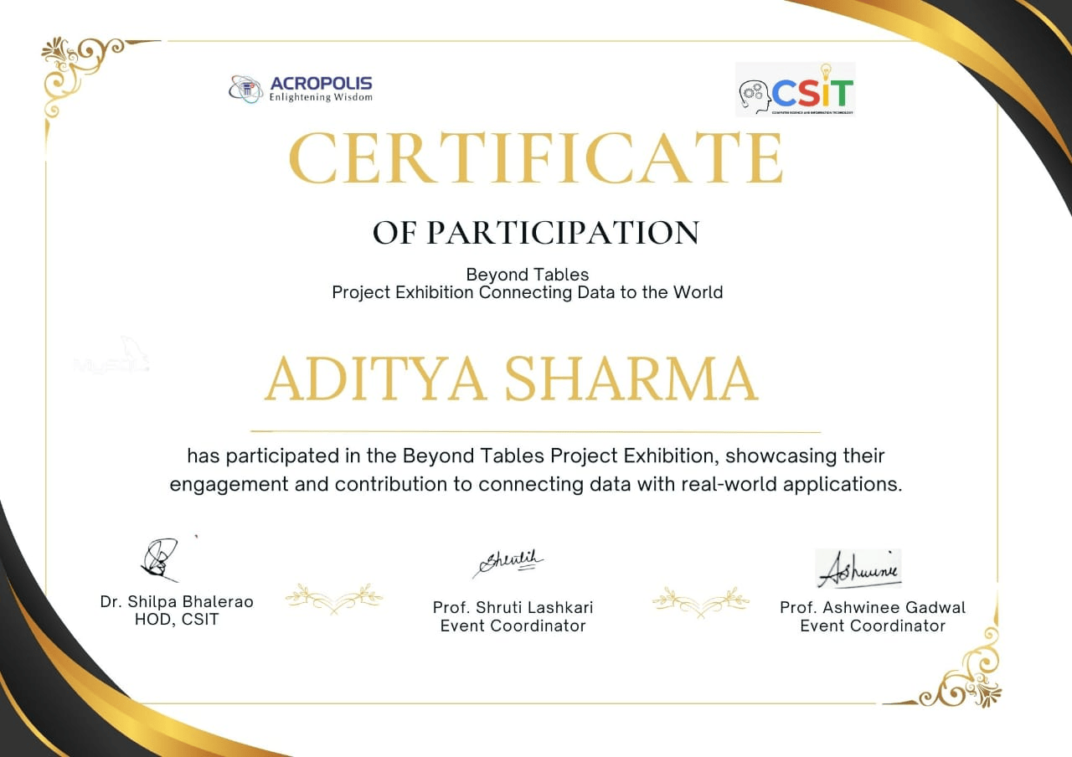

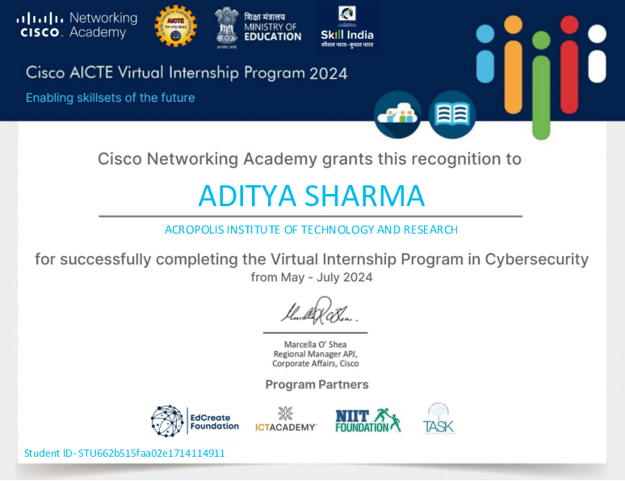

**Nptel Certificates:**

**1. DBMS Mentor: Prof. Shruti Lashkari**

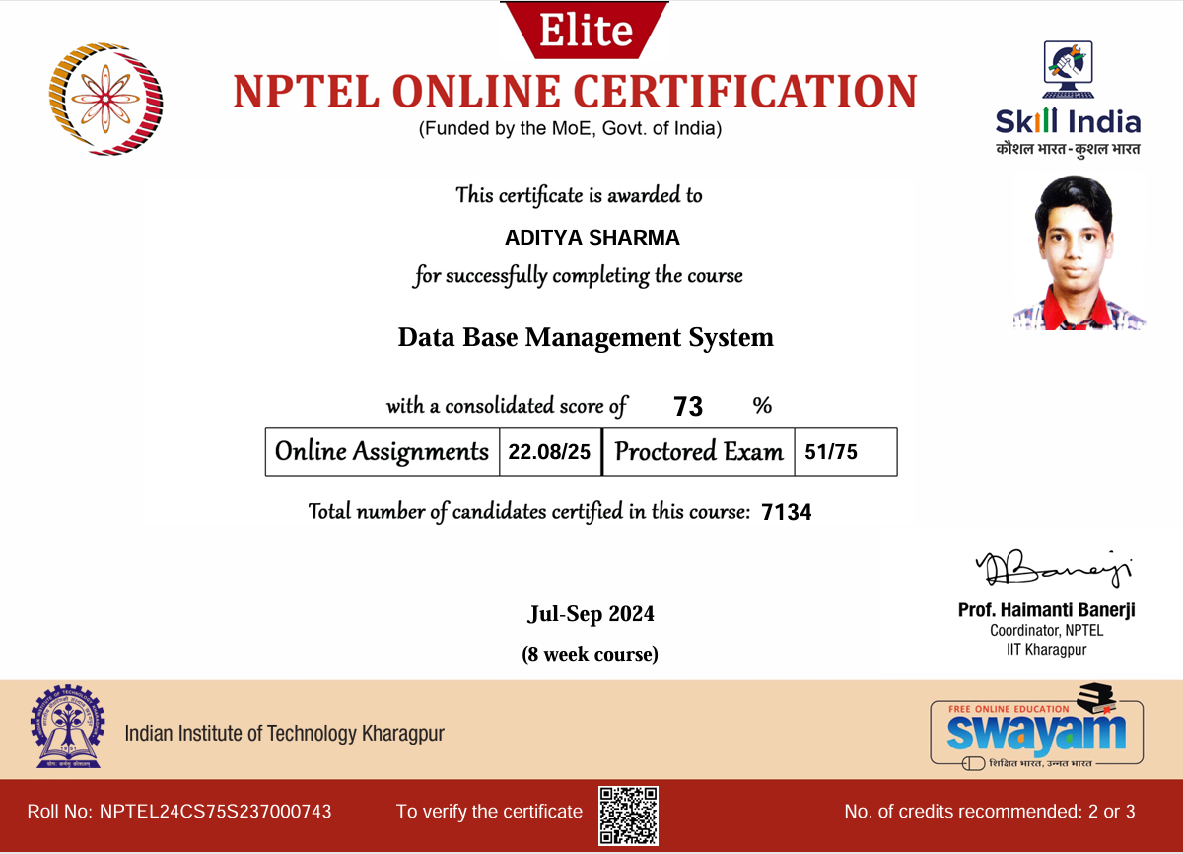

**2. Programming in Java Mentor: Prof. Ashwini Gadwal**

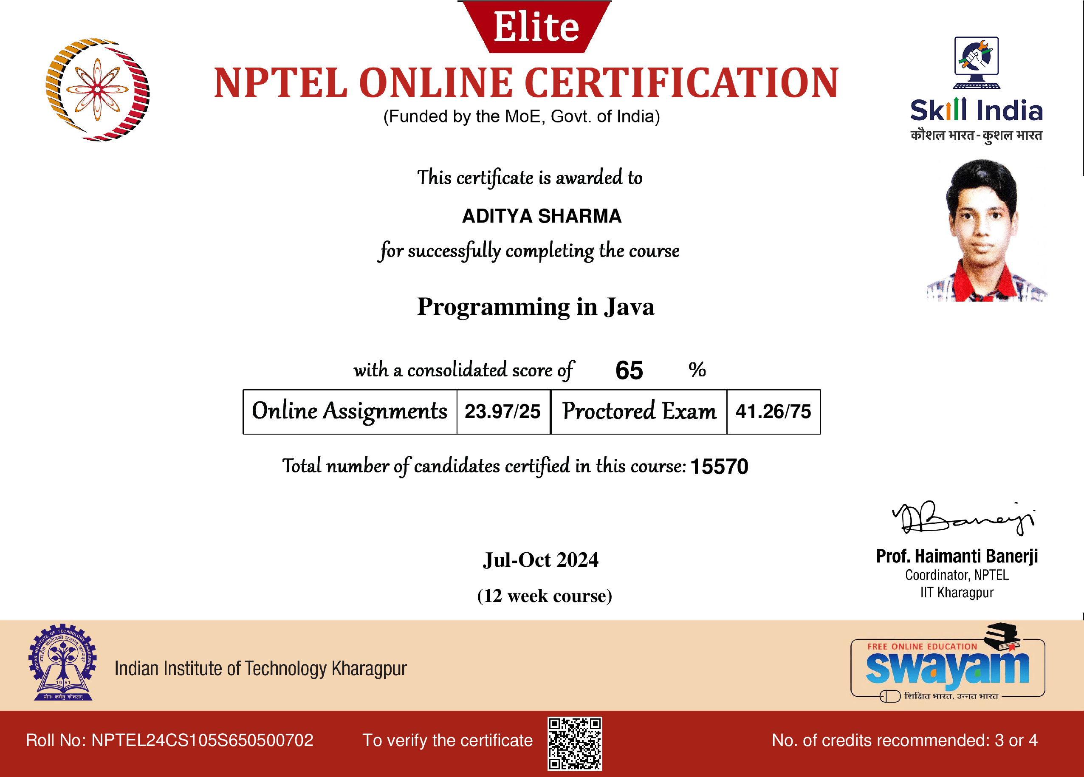

1. **Programming, DSA with Python Mentor: Prof. Chanchal Bansal**

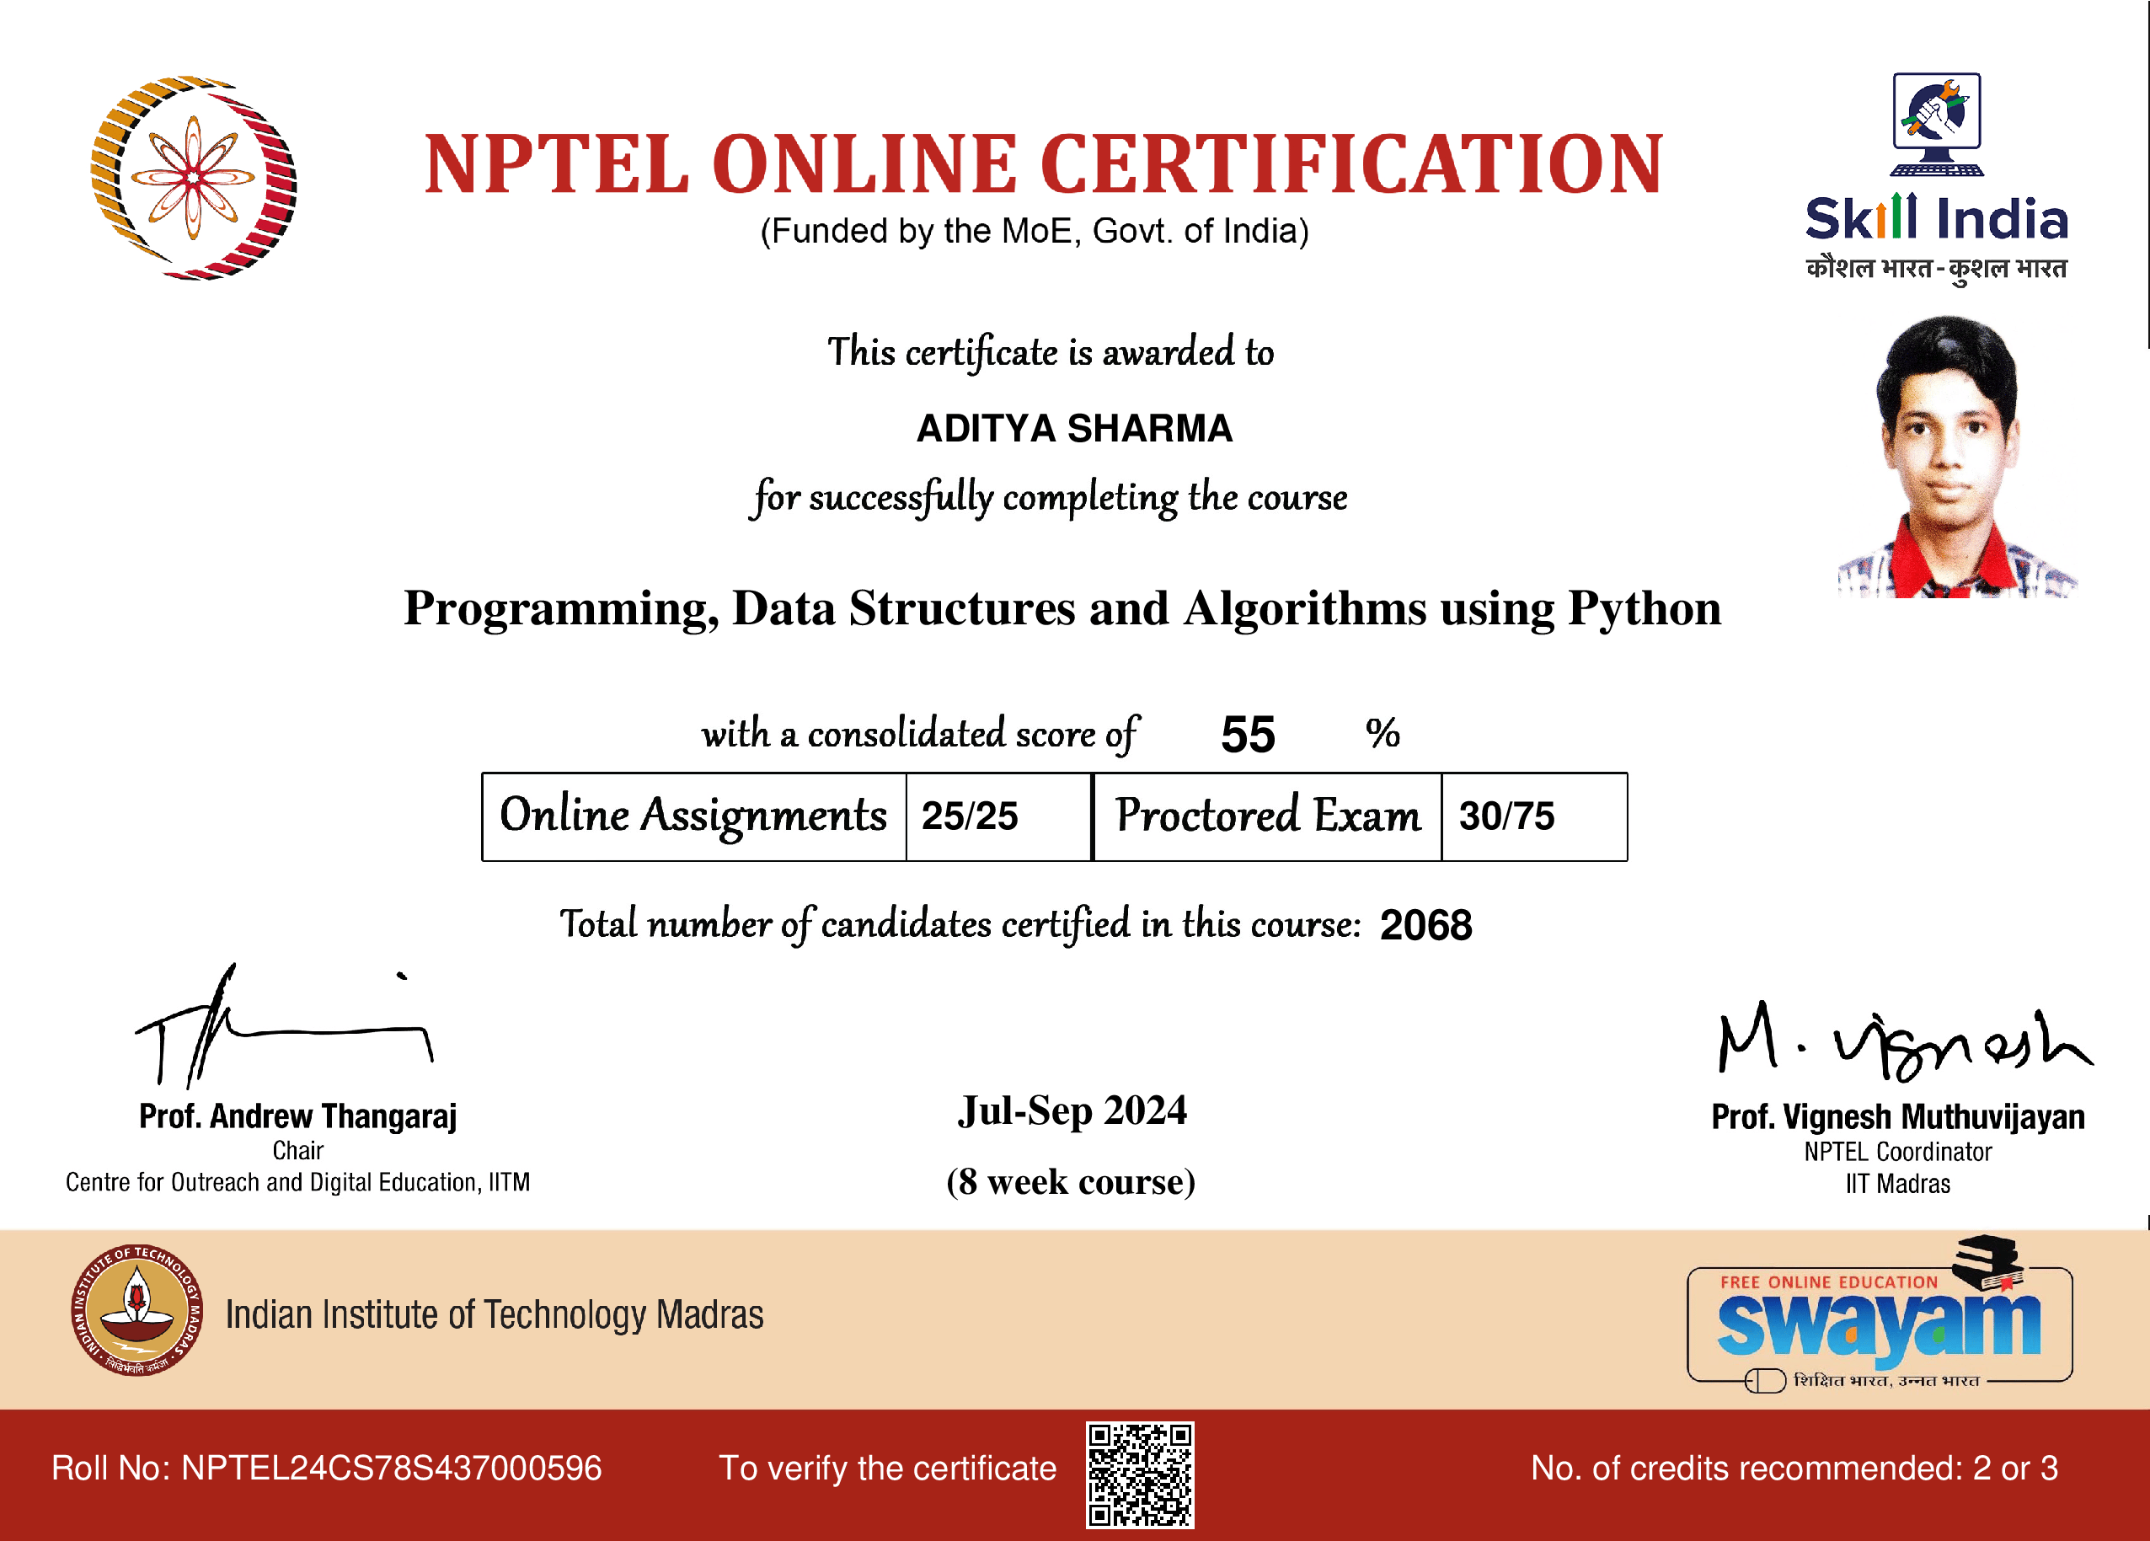

1. **Software Engineering Mentor: Prof. Garima Joshi**

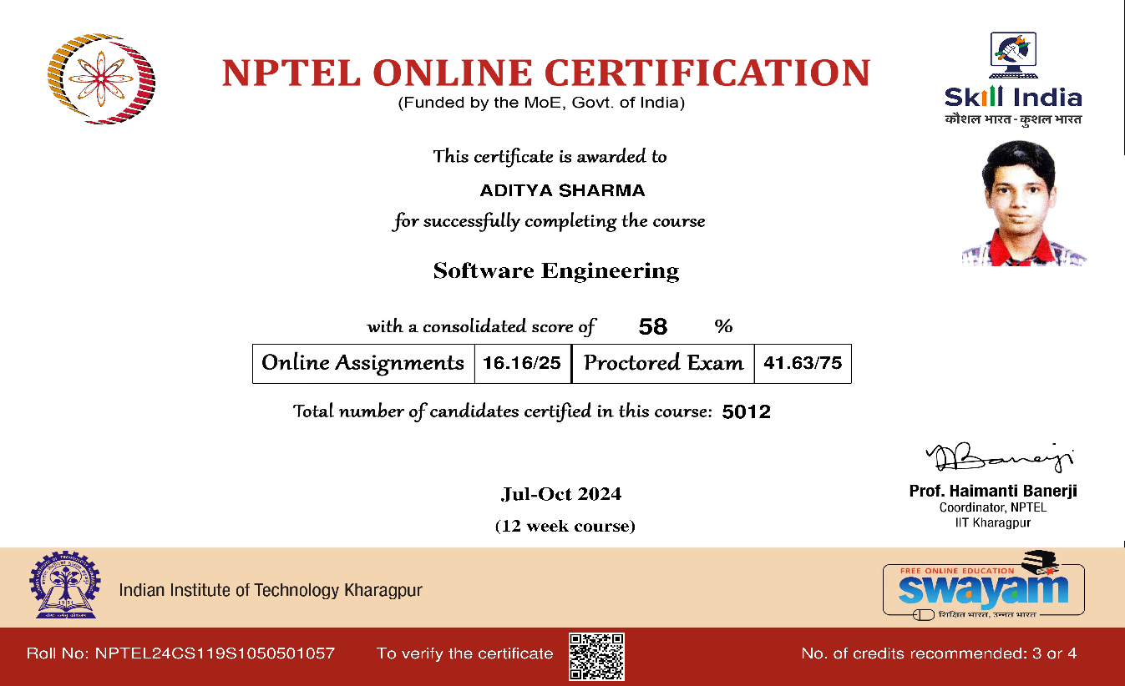

**References/ Bibilography :**

* + **Linkdin :** [**https://www.linkedin.com/in/aditya-sharma-4a2a0b255**](https://www.linkedin.com/in/aditya-sharma-4a2a0b255)
  + **Github :** [**https://github.com/R-8-12**](https://github.com/R-8-12)